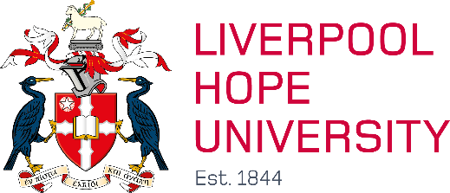

Disability Confident Scheme Declaration

If you are applying under the Disability Confident scheme, please complete this form and return it with your application.

Liverpool Hope University is committed to be an equal opportunities employer. We value and welcome diversity. Liverpool Hope University actively encourages applications from disabled people. As part of this, Liverpool Hope has committed to the Disability Confident scheme. One of our commitments is to offer an interview to all disabled applicants who meet the minimum criteria for the role(s).

By ‘minimum criteria’ we mean that you must provide us with evidence in your application which demonstrates that you meet all the ‘**essential criteria’** as set out in the candidate information pack.

To apply via the Disability Confident scheme, you must have a disability, as defined by the [Equality Act 2010](https://www.legislation.gov.uk/ukpga/2010/15/section/6). Such as a physical or mental impairment which has a substantial and long-term negative effect on your ability to carry out normal day to day activities.

If you require **reasonable adjustments** to enable you to attend for interview, please advise us when you return your application

**Declaration**:

By completing and submitting this form, I confirm that I have a disability and I wish to apply under the Disability Confident scheme, on the understanding that an interview will be offered if I meet the minimum criteria (subject to the terms and conditions of the scheme).

3 of 3

|  |  |
| --- | --- |
| Name |  |
| Date |  |
| Job Reference No |  |